**Reflection on Spatial Crowdsourced Participation**

Baixuan Wang

MA Digital Arts and Humanities

DH6010 Humanities and New Technologies: Tools and Methodologies

##### ABSTRACT

The article introduces the concept of spatial crowdsourcing, followed by reflection and review on my participation in mapping participation. It fills the gap between growing needs for exclusive use of map data and standard commercial map service, but the rising phenomenon is also troubled by issues like privacy and credibility.

##### INTRODUCTION

Recently I participated in some public crowdsourcing exercises, including Humanitarian OSM Tasks(HOT), open street map, Map Swipe, Google Map Local Guide, etc. The level of participation in User Generated Content varies as different platform operating in its own style. Having a clear task for user can improve the quality of crowdsourcing result and speed up project’s progress by setting up priority. It’s a powerful cooperative tool that needs to be spread out with careful design and maintenance. Throughout crowdsourcing, information should be contributed by individuals voluntarily, and platforms are responsible for privacy protection and data safety.

##### SPATIAL CROWDSOURCING

Spatial crowdsourcing is an emerging new platform due to the fast-developing internet culture. Kazemi and Shahabi introduce it as the process of crowdsourcing a set of spatial tasks to a set of workers, which requires the workers to perform the spatial tasks by physically traveling to those locations (Kazemi & Shahabi, 2012).  Considering participant’s privacy and limitation of time that a person can spend on travelling, it’s more reasonable to figure out how to avoid only focusing on nearby space. In their paper, Ghinita and Shahabi introduce a novel privacy-aware framework (Figure 1) for spatial crowdsourcing, which enables the participation of workers without compromising their location privacy. Further, they state that privacy needs protection even before workers consenting to a task (Ghinita & Shahabi, 2014). Without knowing worker’s location, assigning a location to a person may cause long distance travel cost.

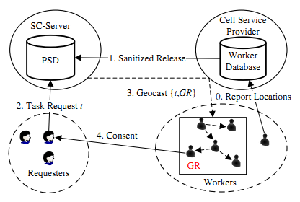

Figure 1 Ghinita and Shahabi‘s Privacy framework for spatial crowdsourcing

However, in disaster mapping, travelling distance is no longer an issue for online volunteers. They could response with a particular focus on the role of volunteered data acquisition and distribution (Zook, Graham, Shelton, Gorman, 2010). It seems mapping service providers also have different attitude on privacy protection as it moves on to an action of pure kindness. On Google Map, when I contribute to a site nearby after joining local guide plan, Google reminds me that my name won’t show up on any information section. Participating’s contribution is totally invisible. It’s against the motivation of gift economy, as contribution is embedded into ultimate data and mixed with commercial work, no one could recognize the good intentions from advertising. For instance, as a milestone of gift economy, the open software movement is characterized by the assumption that its programmers are able to increase their active participation in networking culture, thus increasing their possibilities for greater creativity and job satisfaction, and for greater decision-making or determination (Best, 2003). Programmers share their spare time to develop for free, but not for commercial company. In Google Map, user only gets experience points to level up, but can’t gain as much sense of self-satisfaction from it as from Open Street Map.

What’s worse, if a commercial service requires real-time GPS location data to their server for some reason, it will sound like a digital stalker. It has already owned personal information in YouTube, Gmail and Google+, and has potential intention to analysis data for profit. By contrast, OSM uses an independent account from Open Street Map, and doesn’t ask for personal information. This ensures safety of user’s identity and privacy very well. Another benefit is personalized data analysis and project’s visualization part, from which contributors can check the overall participation. In profile page, the link “overpass turbo” will redirect to a map highlighting the user’s contribution in corresponding project (Figure 2). This profile is public to all users on OSM, which will positively encourage users to participate more frequently.

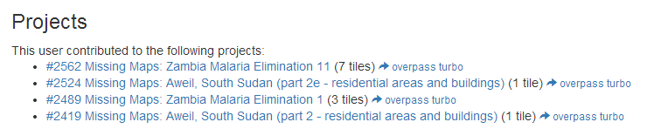

Figure 2 User Profile Page

It’s pretty exciting to have such a helpful tool for with no limitation in geography, but the difference between expert and amateur shouldn’t be ignored. From the analysis shown in Figure 3, the imbalance between works done and validated indicates its shortcoming. At first I supposed the role of validator were a group of people who had more knowledge and experience in this area, but I couldn’t found any restriction for beginners to get involved in that process (unless they consider my account, which was created only 4 months ago, can be trusted). The key point is every account is considered equal right now, but human can make mistakes and may have different standard on mapping roads. I have seen more than 4 types of highways marked by different contributors in a single tile, which appear alike in satellite image. The disordered data may cause confusion for people who rely on the navigation to drive in that area.

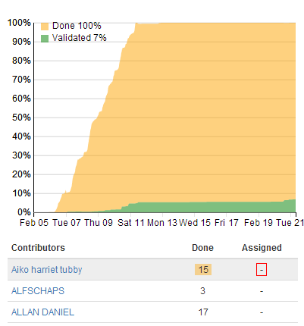

Figure 3 Analysis Section in Project Information Page

##### Learning through practice

After trying out for a while, I decided to use OSM as the major task for my participation in spatial crowdsourcing. I have done some work before in open street map in contributing to my local area, so for OSM there is no need for creating a new account, and to get the application called [OSMTM](http://tasks.hotosm.org/) authorised in open street map only takes one click. Furthermore, once I start mapping, OSM will redirect to open street map and provide a new layer of satellite image as the only reference. Those fundamental connections provide a friendly environment and reduce learning costs for beginners.

Table 1 Projects I participated in OSM

|  |  |  |  |  |  |  |
| --- | --- | --- | --- | --- | --- | --- |
| Project | Author | Requesting organization | Priority | Imagery | Map Feature | Tile(s) finished |
| [#2419](http://tasks.hotosm.org/project/2419) &[#2524 Missing Maps: Aweil, South Sudan](http://tasks.hotosm.org/project/2524) | **Missing Maps** | **MSF** | high | Bing | **residential areas and buildings** | 2 |
| [#2441 Zone 4, Bidibidi Refugee Camp, Yumbe Area, Uganda, Camp – WatSan](http://tasks.hotosm.org/project/2441) | Missing Maps / CartONG | MSF | Medium | Pleiade/ADS | Buildings, residential areas and Roads | 0  (4 tiles validated) |
| [#2489 Missing Maps: Zambia Malaria Elimination 1](http://tasks.hotosm.org/project/2489) | HOT and DigitalGlobe | Multiple | low | DigitalGlobe | Buildings and Roads | 3 |
| [#2562 Missing Maps: Zambia Malaria Elimination 11](http://tasks.hotosm.org/project/2562) | HOT and DigitalGlobe | Multiple | low | DigitalGlobe | Buildings Only | 7 |

Here are three projects that I have worked on, sorted by time. As it states in Table 1, there is an obvious increase in numbers of tiles that I successful finished editing. The first project is for Aweil in South Sudan, with only 1 tile finished at the very beginning. It’s not an easy work for beginners in both open street map and OSM to add details of buildings, residential areas and roads, let alone the fact that I know nothing about local architecture style in Aweil. Thanks to the considerate project description section, they provide an additional OSM diary in their blog to explain how villages and buildings in Aweil appear, I found some images in that post very handy and kept their features in mind while mapping and identifying buildings in and outside central area (Figure 4 & 5). For example, in suburban residential area from the view of top the roof’s outline usually looks like a yellow circle, while buildings in inner circle have regular and square roofs with more variations in colour.

While the second project I tried doesn’t have this kind of interpretation, although they provide a video clip in a village in Uganda, which was recorded by a mobile phone’s camera, and most space was taken by the narrator herself, not local buildings. For this reason, I did some mapping in this area but can’t confidently confirm to finish a tile. The good news is that I gained more knowledge about road features, which I usually don’t have the chance to work on in a half-done area like cork. The simple environment is an ideal training field for beginners.

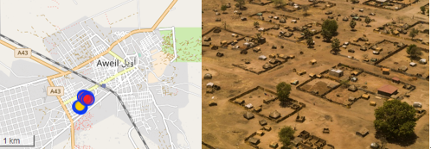

Figure 4 Central Area in Aweil

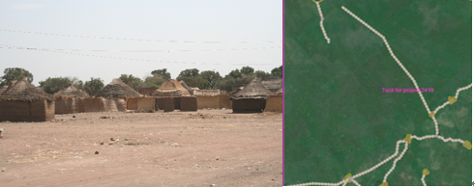

Figure 5 Villages around Aweil

Then it comes to a comfortable stage where I started to edit in project Zambia, in which the aim is to trace buildings and major roads. In previous editing, I developed basic skills like shortcuts for making a circle or a square, duplicating and how to leave an appropriate comment for others to continue unfinished work in open street map and OSM. Then I notice that I left a wrong comment in open street map—–I edited in Cork and Shanghai at one time and upload them in one comment about Cork, this won’t be understood by other contributors in Shanghai. Since comment can’t be deleted by myself, I submitted another comment to explain the mistake. It is quite similar with git, an open source version control system, merely impossible to regret once committed. Literally, probably all the information uploaded to server is difficult to withdraw.

##### COMPARISON BETWEEN MapSwipe AND OSM

Since mobile devices present a much greater possibility for access by those working in disaster response situations in developing countries (Zook, Graham, Shelton, Gorman, 2010), there is no excuse not to participate in a mobile spatial crowdsourcing project and see the difference. MapSwipe is a mobile app for the Missing Maps Project to enable fast satellite image classification. The pre-screen satellite imagery is used to save the time spent on the actual mapping process and improve the quality. Its mechanism is simple but practical. All I need to do is swiping, making judgment and tapping. Tapping once means buildings found in this square, tapping twice means it’s only a conjecture, third means low quality image caused by cloud or some other reason, and no tapping means no building. Simple objective make it possible for contributors to spend tiny spare time to finish the task. What’s more, every successful finding will activate motivational words (Figure 6). It’s truly a well-designed gamification in spatial crowdsourced application.

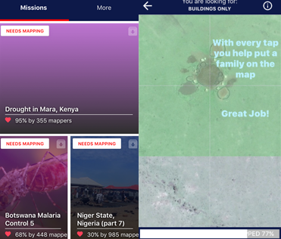

Figure 6 Missions in MapSwipe

Setting up a meaningful goal in crowdsourcing has a significant excitation effect. Both OSM and MapSwipe perform well on it with different complexity. Before I joined OSM, although I had tried several times to contribute in local area, I didn’t know to what extend I needed to fill the map. For a single building I may not have all the metadata in hand such as name, type of building, levels, address, tags and relations. I keep asking myself that is there anyone demanding that information? Am I doing the right thing in some complicated building areas?

In this case, new user of the website may get lost in overwhelming information. For example, I outlined buildings along Western Road near UCC, . By contrast, OSM prepares clear descriptions and instructions, step by step, to guide contributors to the most comfortable starting point. For those who are not familiar with the tasking manager, they can be guided through the description, get to know some unique geographical features of that place, even if they skip some sections using tabs, there is no delay for jumping back to previous tabs from contributing page. Also, important information like map feature is highlighted to make long description more human readable.

Due to the weakness of crowdsourcing, similar with HOT, there should be a well-designed logic loop to ensure credibility in MapSwipe. Two methods can be taken to help with that. One is taking a test at the beginning to check whether the user’s judgement on mapping is reliable is necessary. And considering to assign simple projects at first. After several projects, as the user levels up, then consider to assign harder tasks to experienced contributors. The other is assigning the same tile to more than one user, then comparing the result. If different, mark that tile as “needs to be checked again”, and assign it to another user who has higher level number.

##### CONCLUSION

The inspiration I got from those spatial crowdsourced projects is how to attract and guide the crowd to participate. It requires clear image of future achievement, instant feedback, respect for privacy and detailed instruction. These principles can be further applied into the creation of my digital artefact and collaborative projects when I need to ask other people to give some advice or contribute in other forms.

##### Reference

Kazemi, L., & Shahabi, C. (2012, November). Geocrowd: enabling query answering with spatial crowdsourcing. In Proceedings of the 20th international conference on advances in geographic information systems (pp. 189-198). ACM.

To, H., Ghinita, G., & Shahabi, C. (2014). A framework for protecting worker location privacy in spatial crowdsourcing. Proceedings of the VLDB Endowment, 7(10), 919-930.

Zook, M., Graham, M., Shelton, T., & Gorman, S. (2010). Volunteered geographic information and crowdsourcing disaster relief: a case study of the Haitian earthquake. World Medical & Health Policy, 2(2), 7-33.

##### APPENDIX

12 tiles marked as done:

#2562 Missing Maps: Zambia Malaria Elimination 11 (7 tiles)  
#2524 Missing Maps: Aweil, South Sudan (part 2e – residential areas and buildings) (1 tile)  
#2489 Missing Maps: Zambia Malaria Elimination 1 (3 tiles)  
#2419 Missing Maps: Aweil, South Sudan (part 2 – residential areas and buildings)(1 tile)

4 tiles validated:  
#2441 – Zone 4, Bidibidi Refugee Camp, Yumbe Area, Uganda, Camp – WatSan  
#2562 – Missing Maps: Zambia Malaria Elimination 11

Contribution to local area in Open Street Map  
#1 UCC in Cork  
#2 Campus of Shanghai University